Muhammad Abdullah
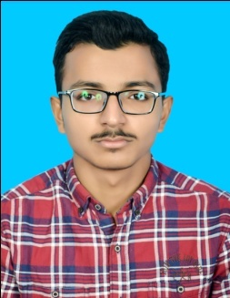
+92 3016813530 – ranamuhammadabdullah123@gmail.com , Age: 17 , https://www.linkedin.com/in/muhammad-abdullah-919995192

Education
MCS NUST, Rawalpindi
Bachelors in Electrical Engineering
2020 (November) –
Sadiq Public School, Bahawalpur
Pre-Engineering
2018-2020
Matriculation in Sciences
2016-2018

Experience
- Chief Editor Sadiq Magazine, Bahawalpur.
- Chief Ambassador at Mr. Electric Solutions.
- Article Writer at Smash Magazine.
- Article Writer at VShine International Kids Magazine.
- Blogger with more than 1.3k followers.
- Writing amazon affiliates and descriptive articles as a free-lancer.
- Vlogger and Short Film Maker.

Awards and Honors
Merit Scholarships
- Got merit scholarship from Sadiq Public School
- Got call for scholarship from applied universities across Pakistan

Writing Recognition
- Was declared best essay writer at Sadiq Public School and was awarded honorary seat of chief editor Sadiq Magazine.

Ambassadorships
- Received an ambassadorship from “Niki Furtado’s Taurus Wallet”.
- Received an ambassadorship from “SNX.fitness”.
- Received an ambassadorship of “Chic NYC Runaway”.
- Ambassador at “Mr. Electric Solutions”.
- Ambassador at “The Opportunities Circle”.

Short Courses:
- Completed VA Amazon TEVTA course.

Participations:
- Participated in Glocal Teen International Conference, Nepal ( 2020 )
- Member of Cross Route Country Club ( Bahawalpur )

Volunteering Experience:
- Volunteered at Green Ribbon Movement Islamabad.
- Volunteering at Shaukat Khanam fund raising campaign.

