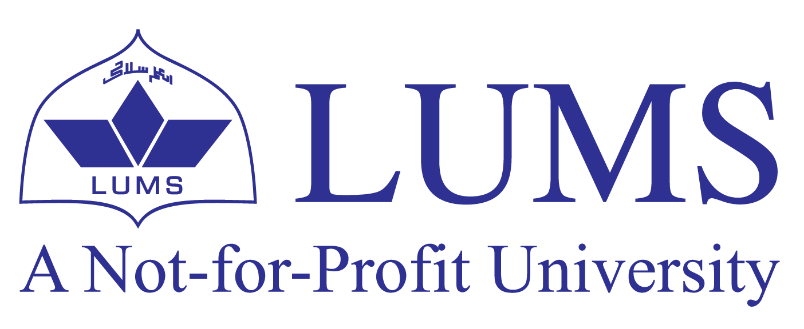
Mian Hassan Mustafa
House no. 177, M-Block, Wapda town, Lahore
(92) 0321-8441619
22110209@lums.edu.pk
https://www.linkedin.com/in/mianhassanmustafa

EDUCATION
Lahore University of Management Sciences (LUMS) Aug 2018 - May 2022
BSc (Honors) in Management Sciences

CERTIFICATIONS
Coursera
Managers Toolkit (- University of London)
Market Research and Consumer Behavior (-IE Business School)
Introduction to Personal Branding (-university of Virginia)

EXPERIENCE
- Intern at Creative Morph June 2020 – July 2020
- I had a four-week internship at Creative morph related to marketing. During this period, I contacted with various organizations internationally for this firm located in Pakistan and generating leads.

- Director at Riayat Lums Chapter June 2020 – July 2021
- I Served as the director finance at Riayat Lums Chapter for a year. Proposed budgets, managed society financials and took part in the decision making regarding future road map of the society. Conducted different drives and online sessions.

- Beyond the Books: May 2019 – July 2019
- I had a six-week marketing internship at this startup whose aim was to work on extra circular and character developing curriculum in underprivileged and government institution.

PROJECTS
RESEARCH PROJECT | - Did research regarding provision of education for child laborers in Pakistan and suggested policies.  - Did various marketing, retail and sales related projects related to food and beverage industry, retailers, and technical firms.  - Calculated co-relation of GDP and life expectancy in Pakistan by using statistical software R.  - Made analysis of stock market and determined the accurate market price of Honda Atlas.

MANAGEMENT PROJECT | - Hosted 3 main iftar and Ration Drives in 3 main cities of Pakistan for more than 3000 people under the umbrella of Madad Foundation.  - Arranged food carnivals at college and a trip at university.  - Lead marketing and HR teams in societies at LUMS.

ADDITIONAL SKILLS AND EXPERIENCE
- Proficient with Microsoft Word, PowerPoint, Excel, Risk
- Public speaking
- Creative Writing

HONOURS AND AWARDS
- 100% Merit Scholarship at College (2016-2018)
- 3 times gold medalist at school while competing with more than 1500 students.
- Got 1st position in Punjab in IKMC.
- Captained badminton team at school.
- Team lead at boys scouting training Ghora gali, Murree.
- Got gold medal at Lums marathon (2019)

EXTRA CURRICULAR
Societies experience
- Director External relations and promotions at Riayat Lums Chapter philanthropic Society at LUMS (2021-present)
- Director HR at Lums Literary society (2020- 2021)
- Assistant Director marketing Department – Sports at LUMS (2020 – 2021)
- Director Events Department -Environmental society LUMS (2020 – Present)
- Member Marketing Department –LUMS Culture society (2019)

Volunteering
- Volunteer at Blood link – LUMS Community Service Society, LUMS 2018
- Volunteered at LUMS annual career fare.
- Volunteered in a fund raiser event for RIZQ LUMS for eradicating hunger across Pakistan.

INTERESTS
- International & Current Affairs
- Entrepreneurship
- Hockey
- Debating

LANGUAGES
Fluent in English Urdu and Punjabi
Know Arabic

