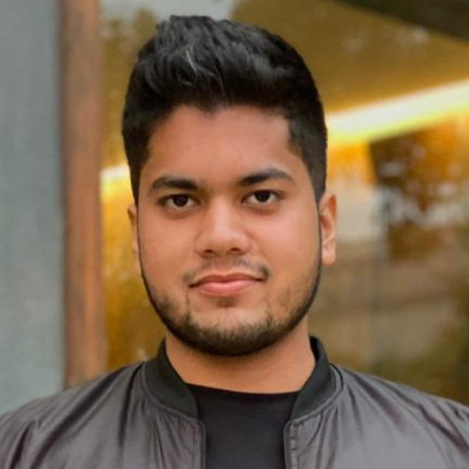Hadi Ali Siddiqui
886-A State Life Cooperative Housing Society
Lahore, Punjab, 54660
03218817379
hadialisiddiqui@outlook.com

EDUCATION_________________________________________________________________
UNIVERSITY OF THE PUNJAB Lahore, Punjab
B.S. Computer Science Candidate (Expected graduation Jun 2022)
- CGPA: 3.83
- Relevant Course: CCNA (Routing & Switching), CCNA (Security)
- Extracurricular Activity: Charity Society

UNIQUE COLLEGE Lahore, Punjab
F.Sc. Pre-Engineering (Sep 2017)
- Extracurricular Activity: Bronze Medal and Certificate of honor in Wrestling awarded at the 6th Inter-School & Inter-Collegiate Games. Certificate of Participation in Wrestling, Bodybuilding, Weightlifting, Rowing and Tug of War.

THE NEW SCHOOL Lahore, Punjab
Matric Science (Jul 2015)
- Award And Honor: Shehbaz Sharif e-Youth Initiative laptop and Certificate of merit for outstanding performance in Matriculation Examination. Gold Medal and Certificate of honor for outstanding performance in Matriculation Examination.

PROFESSIONAL EXPERIENCE________________________________________________
Zanoor Organization Lahore, Punjab
Ambassador Feb 2019 – May 2019

Halogix Lahore, Punjab
Founder & CEO Aug 2020 – Present

AIESEC in Lahore Lahore, Punjab
Team Member Oct 2020 – Present

Maqssoft Lahore, Punjab
Graphic Designer - Intern Oct 2020 – Present

Literary Society PUCIT Lahore, Punjab
Graphic Design Lead Oct 2020 – Present

ADDITIONAL SKILLS_________________________________________________________
- Writing
- Graphic Designing
- Voice Acting

REFERENCES________________________________________________________________
References available upon request

