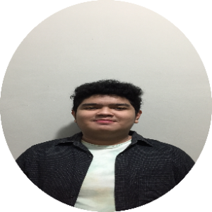 |  | Muhammad Rabby Ilyas  Computer Science College Student
Profile  I am the type of person who likes to do things effectively and precisely. Have an interest in web design and front end development. What I want to achieve is I want to be a Front end Developer.  Contact  PHONE:  0812-6198-6622  LinkedIn:  https://www.linkedin.com/in/rabby-ilyas-45943b213/  EMAIL:  muhammad.ilyas004@binus.ac.id |  | EDUCATION  Bina Nusantara University  Sep 2020 – Present  Senior High School 8 Pekanbaru  2017 – May 2020  WORK EXPERIENCE  Japannese Club Senior High School 8 Pekanbaru  Participant  2019–2020  My responsibility in this club is, I assisted various events held by the club and I assisted and participated in every session held by the club.  SKILLS

