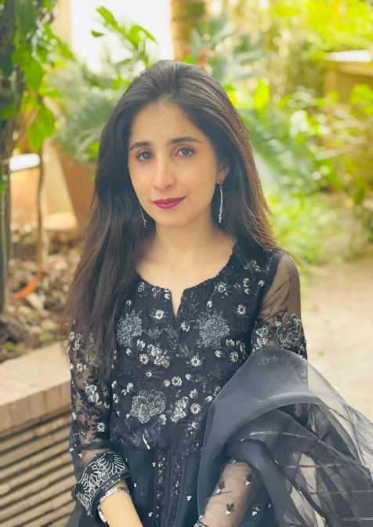
Malika Abid (student)
Email address: 24020205@lums.edu.pk
contact: 03228542121

Education:

Froebel’s International school
[Straight A’s in internal exams throughout school]
EDEXCEL-O levels 3A*4A’s

Lahore University of Management Sciences
2020-present
First year CGPA 3.78

Skills:

Took C++ and Python courses in both semesters, have introduction level experience in coding, programming and data analysis in both languages.

Took philosophy, writing and communication courses in first year of university so have a wide experience in writing, creative writing, report writing, web content writing, academic writing.

Extra activities:

Science/Math
Founder 'Girls for STEM' society in high school:
Arranged motivational lectures;workshops to promote female participation;held debates on Pakstani women underrepresentation in STEM

Social Justice
Intern, Paiman Alumni Trust (NGO):
Assisted my team in the deradclization of female madrassah students;arranged peace painting competitions;arranged food drives for religious minorities

Debate/Speech
Member of School Debating Society:
Administered logistics, organized interschool competitions and events , initatiated midldle school debating competitions

Journalism/Publication
Freelance Blogger for Express Tribune & Dunya News:
Blogs on psychology of happiness, youth empowerment, peace and inter-faith harmony.

Art
Passionate shibori maker:
Learned Miura,Kumo,Itajime shibori techniques; exhibited it in inter school art competitions.

Science/Math
Head of Science and Math society - Froebel's:
Logistical management; arranged STEM competitions in school; represented school in science fairs; won under-20 national runner-up award

Community service( Volunteer)
Volunteer, Muniba Mazari, Pakistan UN Ambassador:
Advocated for the rights of transgender; provide food and clothing supplies to transgender community, orphans and handicapped.

Enviormental
Eco-friendly Officer, WWF internship:
Set-up water filteration plants, Team lead for designing eco-friendly shelters.

Community service( Volunteer)
Volunteer at SOS Village:
Taught creative writing and character building to orphan children; arranged arts competition and collected donations for the organization.

Theater/Drama
Sub-Directed 'Mujhay Jeena do' (let me live) drama:
Targeted to raise sexual harassment awareness in Pakistan; learnt basic directing technique; secured funding from Ministry of Human Right

Culinary
Member of lums culinary society:
Traveled with my society to review different new restaurants and cafes.

Communication
Head of lums Islamabad meetup:
Managed to gather all lums Islamabad students at one place to finish the gap created by online setup and build a university community which is lacking in the current pandemic situation.

