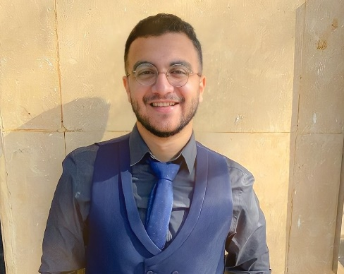
Ali Elden Atef Ahmed Fouad

01124365087
Alieldin255@gmail.com
Shoubra, Cairo

Profile summary

Fresh graduate person who wants to work with a community where able to utilize his intrapersonal skills and make the company more effective and productive.

Work experience

- Medical Sales Representative at Nerhadou International Company (Dec2020 -April2020)
Responsibilities:
  - Making Regular Visits to All the Customers (Doctors, Pharmacists, Hospitals and Distribution Companies) And Delivering Them the Message of The Company’s Policy.
  - Highlighting The Competitive Privileges in The Company’s Products
  - Providing And Informing Doctors with The Studies and Scientific

(I Acquired Communication Skills, Negotiation Skills, Pharmaceutical Knowledge, Quality Control Knowledge, The Company's Sales Increased by A Very Large Percentage After Working in It, And the Company's Knowledge Increased by 200 Clients.)

- Operations Coordinator At 3D Diagnostics
(July2019-Sep2019)
Responsibilities:

  - Manage Operations Workflow.
  - Prepare Cases' Materials.
  - Manage Cases After Processing to Be Ready for Production.

(I Acquired a Lot of Skills Such as Team Working, Communication Skills, Software Skills and Time Management)

Skills

- Negotiation skills
- Excellent communicator
- Flexible
- Analytical skills
- Graphic Design
- Social media moderation
- Social media monitoring

Education

- Udacity Digital marketing Challenger track (may2021-may2021)

With the ‘Digital marketing’ specialization I became qualified to win my spot as a freelancer digital marketer who can land big gigs anywhere
I learned:
  - Plan content strategy
  - Create and curate content.
  - Optimize landing pages.
  - Measure the impact.

- Bachelor’s Degree In science (chemistry &Geology) Department GPA 2.56 (Very good Grade)
(Sept 2015 – May 2019)

Volunteering

- PR Member at Infinity team
- Marketing specialist (Facebook page moderator) at infinity
- PR Member at AAPG (American Association of Petroleum Geologists)
- HR Member at AAPG (American Association of Petroleum Geologists)
- PR Vice President at Infinity
- Delegate At Map (Model of American Presidency)
- Delegate At Mac (Model of Congress)

Language

- English: conversational
- Arabic: mother tongue

